
Allergic Rhinitis
Marshall Plaut, M.D., and Martin D. Valentine, M.D.
Volume 353:1934-1944 November 3, 2005 Number 18

This Journal feature begins with a case vignette highlighting a common clinical problem. Evidence supporting various strategies is then presented, followed by a review of formal guidelines, when they exist. The article ends with the authors' clinical recommendations.
A Baltimore college student has rhinorrhea, sneezing, nasal congestion, and itchy, watery eyes in the spring. He reports having had similar symptoms the previous spring. Over-the-counter allergy pills have failed to help his symptoms and caused dry mouth and somnolence. He wants relief and assurance that he will not be ill, have dry mouth, or feel drowsy during final examinations. On physical examination, his conjunctivae are injected, and his nasal mucous membranes are pale, wet, and boggy. What are your recommendations?
The Clinical Problem
Characteristics of allergic rhinitis and conjunctivitis¹ include sneezing, watery rhinorrhea, and nasal congestion; itchy palate; and itchy, red, and watery eyes. Blockage of the eustachian tubes, cough, and a sensation of pressure in the sinuses result from edema and venous engorgement of the nasal mucosa.^{2,3} Allergic rhinitis occurs when inhaled allergens interact with IgE antibodies on cells in the airway.⁴ Estimates of the prevalence of allergic rhinitis in the United States range from 8.8 percent⁵ to 16 percent.⁶
Strategies and Evidence
Evaluation
History and Physical Examination
The history helps establish seasonality, year-to-year persistence, potentially inciting factors, and complicating conditions (including sinusitis, nasal polyps, and asthma). These conditions occur more frequently in patients with allergic rhinitis than in control populations; in one study, 19 to 38 percent of patients with allergic rhinitis were found to have coexisting asthma.⁷
The diagnosis can generally be made on the basis of the history and physical examination. The examination should easily detect signs of rhinitis and conjunctivitis and may reveal wheezing suggestive of associated asthma. Spirometry is useful in detecting subclinical asthma, and computed tomography most reliably reveals sinusitis in patients with symptoms of refractory rhinitis. Additional testing may be helpful if the diagnosis is uncertain or if the response to therapy is suboptimal. For example, blood or nasal eosinophilia suggests an allergic cause, whereas neutrophilia points to an infectious cause.
The severity of allergic rhinitis is assessed² by assigning numerical values for eye symptoms, nasal itching, sneezing, rhinorrhea, and nasal congestion (with 0 denoting none, 1 mild, 2 moderate, and 3 severe), taking into account subjective intensity and whether these symptoms interfere with sleep, leisure, and school or work activities, or the duration of symptoms each day (with 0 denoting none, 1 denoting less than 30 minutes, 2 denoting 30 minutes to 2 hours, and 3 denoting more than 2 hours).
Allergy Testing
Allergy testing is performed in order to confirm which allergens are relevant to the symptoms and which should be included in immunotherapy regimens. Culpable allergens can be identified by skin or in vitro tests for the presence of allergen-specific IgE antibodies.¹ A patient with an annual recurrence of symptoms is likely to be reacting to seasonal pollen or other environmental triggers. Allergens contained in dust-mite excreta, in the epidermis and saliva of furred pets, in cockroach bodies, and in fungal spores are present year-round. Testing is typically performed with a set of allergens relevant to the patient's environment. For example, a cat owner in Maryland with year-round symptoms might be tested with extracts of pollen from local trees, grasses, and weeds, as well as with allergens from house-dust mites, cockroaches, mold spores, and cats. The wheal and erythema response 15 to 20 minutes after the "prick" or intradermal application of the allergen is compared with negative (saline) and positive (histamine) controls.
In alternative procedures, in vitro tests for serum IgE antibody to allergens — including varieties of the radioallergosorbent test and enzyme-linked immunosorbent assay — estimate the amount of allergen-specific IgE antibody in a patient's serum, with sensitivity and specificity equal to that of skin testing. Although skin testing carries a very small risk of a systemic allergic reaction,² the immediacy of test results, which enables the practitioner to recommend strategies for allergen avoidance and provide the basis for an allergen immunotherapy regimen, is appealing.
Allergen Avoidance and Pharmacotherapies
Treatment strategies depend on modulation of the immune response so as to interfere with the function of IgE antibodies, interruption of the release of antigen-induced autacoids (histamine and eicosanoids) from IgE-sensitized cells, inhibition of the autacoid effect at receptor sites, and the resolution of allergic inflammation.
Allergen Avoidance
Although allergen avoidance is generally included in a treatment plan for allergic rhinitis, controlled trials of the avoidance of outdoor allergens by staying indoors are not feasible. Limited studies, which were reviewed in a meta-analysis⁸ of the avoidance of house-dust mites with the use of high-efficiency particulate air (HEPA) filters (in one study), acaricides (in two studies), and mattress covers and hot-water laundering of bedding (in one study), demonstrated that active treatment reduced both the levels of house-dust mites and rhinitis symptom scores. In children with allergen-driven asthma, environmental interventions reduced wheezing in proportion to the reduction in the levels of cockroach and house-dust-mite allergens; however, effects on allergic rhinitis were not evaluated.⁹
Randomized trials involving patients with allergic rhinitis showed the effectiveness of several therapeutic approaches (Table 1). ^{2,10,11,12,13,14}
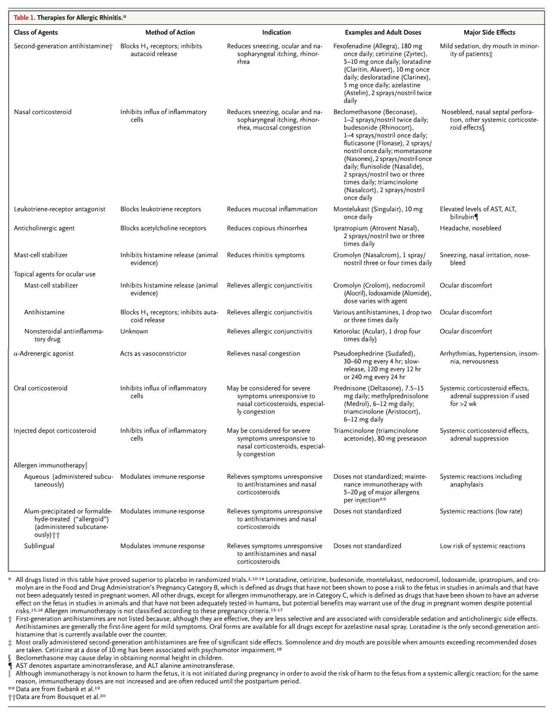
Oral Antihistamines
Antihistamines²¹ were introduced more than 50 years ago for the treatment of allergic rhinitis. However, although these first-generation antihistamines are clinically effective, their use is limited by their anticholinergic and sedative effects, such as impaired performance of tasks,² although some data suggest that the magnitude of the effects on performance has been overstated.²² More recently, second-generation antihistamines lacking substantial sedative properties have largely supplanted the earlier drugs (Table 1). Antihistamines substantially reduce symptoms of nasal itching and watery eyes and have moderate but clinically and statistically significant effects in reducing rhinorrhea and sneezing. However, these agents have minimal effects on the symptoms of nasal congestion.^{2,23} Clinical trials comparing various second-generation antihistamines demonstrate approximate equivalence in the reduction of symptoms, with only small and inconsistent statistical differences.^{21,24} There is no evidence that any particular drug in this class is superior on the basis of the type of allergen inciting symptoms.
Some observers have suggested a combination of a first-generation over-the-counter antihistamine (all of which are soporific) at bedtime and a second-generation antihistamine during the day. However, the efficacy and side effects of such regimens have not been rigorously evaluated, and next-day sedation has been observed with such a regimen.²⁵
Nasal Corticosteroids
Nasal corticosteroids are recommended as first-line therapy for moderate-to-severe allergic rhinitis.² Second-generation antihistamines are generally preferred for the treatment of mild allergic rhinitis owing to their safety and ease of use, although nasal corticosteroids are also considered safe.
Symptoms, including nasal congestion, are better relieved by nasal corticosteroids than by placebo.² A meta-analysis has compared the effects of oral antihistamines and nasal corticosteroids with respect to symptoms of allergic rhinitis. There was a clinically and statistically significant benefit to nasal corticosteroids over antihistamines for nasal congestion and sneezing. In contrast, there was no significant difference between nasal corticosteroids and antihistamines in relieving ocular symptoms.¹⁰ Similar results were obtained in a meta-analysis of nasal antihistamines and nasal corticosteroids.¹¹
The Montreal protocol, an international treaty to protect the ozone layer, dictates the eventual replacement of medications using chlorofluorocarbon-based propellants. Aqueous preparations of nasal corticosteroids with negligible systemic activity have replaced Freon-propelled products. Recently, the Food and Drug Administration has approved a product using hydrofluoroalkane as the propellant.²⁶ All nasal corticosteroids have been more effective than placebo in preventing symptoms of rhinorrhea and nasal obstruction when used daily during periods of allergen exposure.²⁷ Table 1 lists currently available preparations.
Nasal corticosteroids have relatively few adverse effects.^{27,28,29,30} The most common effect is epistaxis, which occurs in 10 percent of cases³¹ and rarely requires discontinuation of the drug. A delay in the attainment of normal height has been reported in children using intranasal beclomethasone but not other nasal corticosteroids²⁹; increased intraocular pressure and posterior subcapsular cataracts have been reported in adults.^{28,30} However, these complications are uncommon and less likely with doses administered intranasally than with the higher doses sometimes used for oral inhalation in asthma.^{28,30}
Antihistamines Combined with Nasal Corticosteroids
Data are lacking from rigorous studies to demonstrate that combination therapy with antihistamines and nasal corticosteroids is superior to nasal corticosteroids alone. Because antihistamines and nasal corticosteroids influence different pathogenetic mechanisms, patients with moderate or severe symptoms are commonly treated with both. In practice, combination therapy is often used for patients who do not have a response to a single agent. In a study testing an algorithm for management, such therapy was the standard for patients with moderate or severe rhinitis.³² After control of symptoms with the use of combination therapy, it is reasonable to attempt to discontinue one of the agents when symptoms have abated.
Leukotriene-Receptor Antagonists
The leukotriene-receptor antagonist montelukast is superior to placebo in relieving nasal symptoms in patients with allergic rhinitis.¹² However, the drug is relatively weak as monotherapy. A meta-analysis demonstrated that, as compared with placebo, montelukast induced a moderate but significant reduction in scores for daily symptoms of rhinitis; in comparison, nasal corticosteroids induced a significant and substantial reduction in symptom scores.¹² Thus, montelukast's role is generally as an adjunct in the treatment of a patient who does not have an adequate response to an antihistamine, a nasal corticosteroid, or both. However, there are no clear data demonstrating that leukotriene-receptor antagonists combined with either antihistamines or nasal corticosteroids reduce symptom scores more than the antihistamines or corticosteroids alone.
Mast-Cell Stabilizers
The cromone cromolyn is available over the counter for intranasal use. It has proved to be significantly better than placebo at reducing nasal symptoms in some trials, but data are inconsistent, and its effects are modest. Cromolyn may be more effective when administered just before exposure to an allergen,² such as when a person with a sensitivity to feline allergens visits a cat owner.
Ophthalmic Preparations
The mast-cell stabilizers, ocular antihistamines, and the nonsteroidal antiinflammatory drug ketorolac are all used topically in ophthalmic preparations for allergic conjunctivitis (Table 1). Randomized, controlled trials have demonstrated that these agents significantly reduce ocular symptoms, including itching, and improve sleep.³³ For predominantly ocular symptoms, one of these preparations alone may suffice. Patients with refractory ocular symptoms should be referred to an ophthalmologist.
Intranasal Agents
Nasal antihistamines are considered to be similar in efficacy to oral antihistamines,^{2,10,11} and one trial suggested that nasal antihistamines relieve total nasal symptoms (and rhinorrhea, specifically) more effectively than oral antihistamines.³⁴ Nasal ipratropium, a quaternary ammonium compound related to atropine, relieves rhinorrhea in patients with allergic rhinitis, with effects similar to those of nasal corticosteroids in one study.³⁵
-Adrenergic Agonists
Pseudoephedrine, an -adrenergic–receptor agonist, counters vascular engorgement of the turbinates, improving nasal air flow.³⁶ There have been few evaluations of pseudoephedrine alone. In one study, the combination of pseudoephedrine and an antihistamine was significantly more effective in reducing total nasal symptoms, including nasal congestion, than was either agent alone.³⁷ Another report showed that the combination of an antihistamine and pseudoephedrine was at least as effective as nasal beclomethasone for nasal symptoms and was superior for relief of ocular symptoms.³⁸ Some patients with severe nasal congestion that is resistant to treatment with a nasal corticosteroid may respond to a combination of antihistamine and pseudoephedrine. However, pseudoephedrine should be used cautiously in patients with coronary artery disease, hypertension, diabetes, or hyperthyroidism and in those receiving monoamine oxidase inhibitors, given its sympathomimetic effects. The drug may also aggravate narrow-angle glaucoma and symptoms of bladder-neck obstruction.³⁶
Systemic Corticosteroids
Rarely, patients with severe symptoms who do not have a response to or are intolerant of other medications may be treated with either oral or injected systemic corticosteroids. Treatment regimens include either a preseasonal intramuscular injection of a dose of depot corticosteroids (the equivalent of 100 mg of prednisone) or oral corticosteroids, administered for several weeks in either alternate-day or daily doses of the equivalent of 7.5 to 15 mg of prednisone, although starting doses as high as 20 to 40 mg of prednisone per day may be required for complete relief of symptoms.³⁹ One controlled trial showed that the depot injection was more efficacious than oral therapy,⁴⁰ but there is concern that suppression of endogenous corticosteroids might be greater with parenteral injections. The well-recognized risks associated with the prolonged use of corticosteroids make other therapies preferable.
Algorithm-Guided Treatment
A recent controlled study³² found that therapy directed by a set of simple guidelines was more effective than therapy chosen by physicians. The selection of a regimen — either an oral antihistamine (for mild rhinitis) or a combination of oral antihistamine and intranasal corticosteroid (for moderate or severe rhinitis) — was based on a visual-analogue scale of 0 to 100 mm for the severity of symptoms of nasal discharge, nasal congestion, and sneezing. Patients whose scores were 50 mm or more for any one of the symptoms were categorized as having moderate-to-severe disease. In addition, ocular cromone was used for moderate or severe conjunctivitis on the basis of a visual-analogue scale for severity of conjunctivitis. The study predominantly included patients with moderate or severe rhinitis. Patients who were randomly assigned to receive treatment as outlined in the algorithm had significantly less severe symptoms and better indexes of quality of life than those in the control group, perhaps because 84 percent of the patients received inhaled corticosteroids, as compared with 32 percent in the control group.³²
Allergen Immunotherapy
According to expert guidelines, allergen immunotherapy should be considered for patients who continue to have moderate-to-severe symptoms despite therapy, who require systemic corticosteroids, who have an inadequate response to the recommended doses of nasal corticosteroids, or who have coexisting conditions such as sinusitis, asthma, or both.
Subcutaneous allergen immunotherapy consists of an open-ended schedule of weekly doses of a solution containing the culpable allergens that gradually increase to an optimal maintenance dose (Table 1).¹⁹ Maintenance doses are often given at intervals ranging from two to six weeks; data are lacking to compare various dosing frequencies. The magnitude of symptom reduction during immunotherapy is variable, although in some trials patients had a reduction of more than two thirds in symptoms and medication scores.⁴¹ Immunotherapy may also confer long-term benefits; it is the only intervention for allergic rhinitis that alters the natural history of disease.
In one study of adults with allergic rhinitis who were treated with immunotherapy, a reduction of two thirds in symptoms and medication scores persisted for at least three years after the termination of treatment.⁴¹ A number of studies have shown persistent effects after allergen immunotherapy was stopped.⁴² In addition, in a study of children between the ages of 6 and 14 years with allergic rhinitis, those who had been treated with immunotherapy had a significantly lower rate of the development of asthma than those who had not been so treated (25 percent vs. 45 percent after three years of immunotherapy).⁴³ In the subgroup of children who were sensitized to only a single allergen (house-dust mite), as distinguished from those sensitized to multiple allergens, the likelihood that IgE antibodies would develop into new allergens was markedly lower among patients who had undergone immunotherapy than among those who had not.^{44,45} The mechanisms underlying these effects are not fully understood.
However, the risk of systemic reactions during immunotherapy is substantial. Approximately 5 to 10 percent of patients who receive allergen immunotherapy have systemic reactions, which are moderately severe in 1 to 3 percent of patients; rarely, patients have even died from anaphylaxis.^{2,23,46,47} Other problems with immunotherapy include the nuisance of frequent injections and uncertainty regarding the optimal strength of extracts and the stability of allergen mixtures.⁴⁸ Thus, despite its benefit and evidence that it is cost-effective,²³ immunotherapy is generally considered a second-tier therapy. Issues concerning immunotherapy in pregnancy are addressed in Table 1.
Subcutaneous immunotherapy with allergens modified by precipitation with alum or chemically treated with formaldehyde or glutaraldehyde ("allergoids")²⁰ is used in Europe, although not in the United States. There are data indicating that its efficacy is equivalent to that of standard subcutaneous immunotherapy.²⁰
Allergen immunotherapy can also be administered sublingually. Although mild oral and sublingual itching occurs, there have been no reports of systemic reactions to this therapy despite extensive use in Europe. The rarity of systemic reactions suggests that this therapy is safer than subcutaneous immunotherapy. However, the efficacy of sublingual therapy is apparently less than that of subcutaneous immunotherapy.⁴⁹ Sublingual immunotherapy is not yet available in the United States.
Areas of Uncertainty
Long-term effects of immunotherapy (for example, the potential to reduce the risk of the development of asthma) require further study. Another potential approach is the administration of a humanized monoclonal anti-IgE antibody (omalizumab). In a placebo-controlled trial, this treatment resulted in a reduction in symptoms of more than 50 percent,^{14,50} and the combination of omalizumab and allergen immunotherapy had at least additive effects.⁵¹ However, this agent is not currently approved for the treatment of allergic rhinitis and is costly.
Recent experimental approaches to immunotherapy for allergic rhinitis have involved the use of agents that stimulate the innate immune system through specialized toll-like receptors (TLRs) — either TLR9 (stimulated by immunostimulatory sequences of DNA)⁵² or TLR4⁵³ — or immunization with peptides of allergens. TLR9 stimuli have been provided either alone or conjugated to allergens. Further work is required to evaluate the efficacy and safety of such therapies and to determine whether the preparation of large numbers of conjugated allergens is feasible.
Guidelines
Four sets of guidelines from expert panels, two in the United States and two in Europe, are shown in Table 2.^{2,23,54,55} These guidelines are in general agreement with one another and with the discussion in this article.
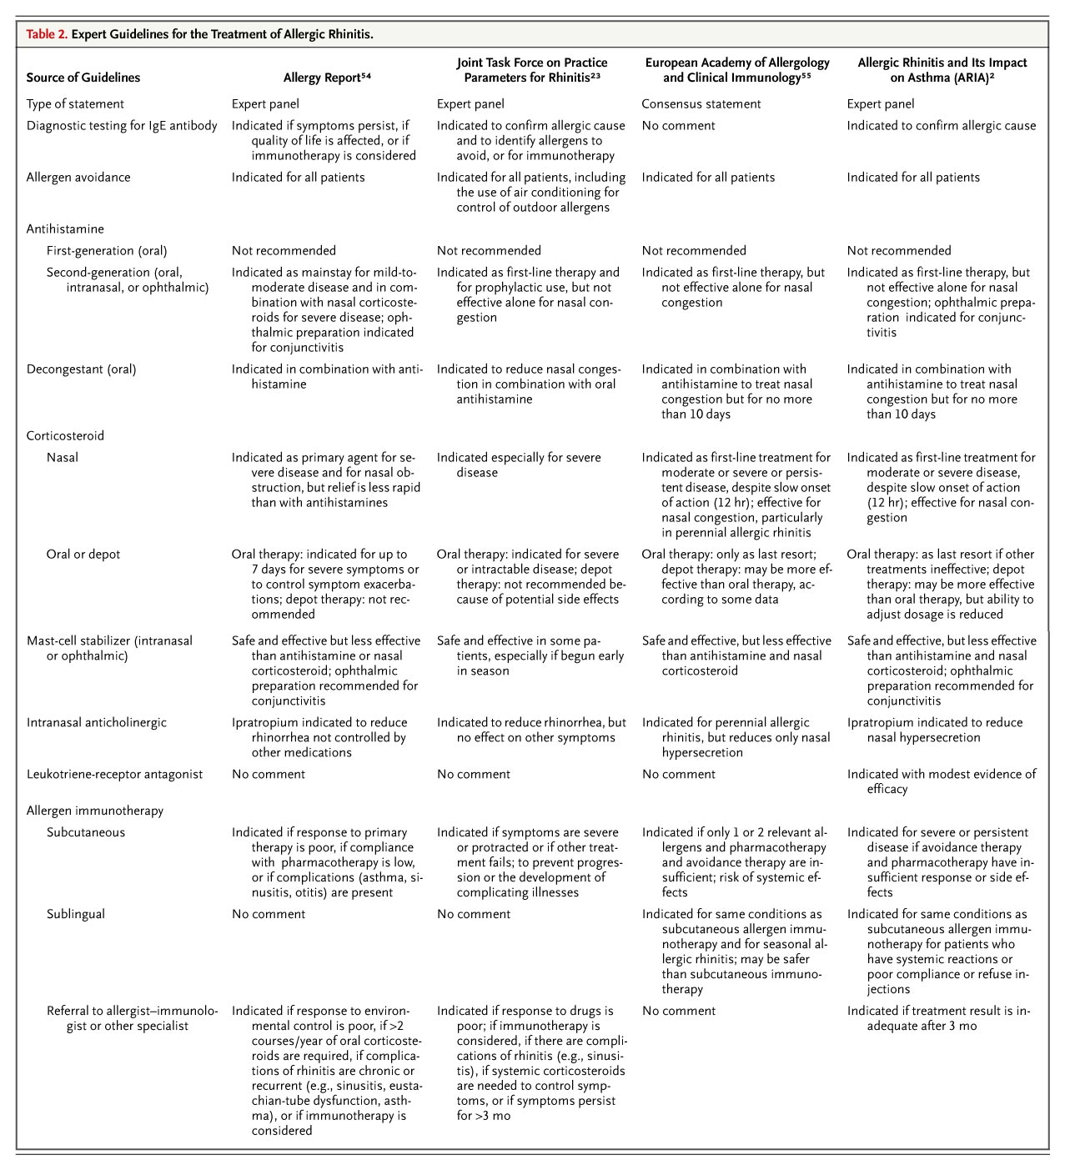
Summary and Conclusions
Mild symptoms of allergic rhinitis are easily ameliorated with either an oral antihistamine or a nasal corticosteroid alone. For patients with moderate-to-severe symptoms of allergic rhinitis with nasal congestion as a predominant finding, such as the student in the vignette, therapy should generally be started with the daily use of a nasal corticosteroid, which would reasonably be combined with a second-generation oral antihistamine (Table 3). Therapy should be started before the anticipated appearance of allergens and continue during the time of likely exposure. In the case described, this would mean starting before the appearance of tree pollen in the Baltimore area (usually in early March) and continuing through the peak of the grass-pollen season in May and June. If eye symptoms persist, an ocular antihistamine could be added. If symptom relief is incomplete, if there is a need for a high inhaled dose of a corticosteroid or a systemic corticosteroid, or if rhinitis is complicated by asthma or sinusitis, the initiation of immunotherapy (on the basis of the patient's history and allergy testing) before the next season of symptoms should be considered.
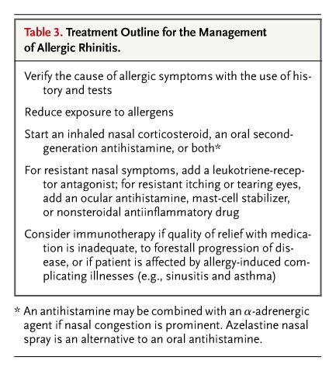

REFERENCES
- Valentine MD, Sanico A. Allergy and related conditions. In: Barker LR, Burton JR, Zieve PS, eds. Principles of ambulatory medicine. 6th ed. Baltimore: Lippincott Williams & Wilkins, 2003:387-405.
- Bousquet J, Van Cauwenberge P, Khaltaev N. Allergic rhinitis and its impact on asthma. J Allergy Clin Immunol 2001;108:Suppl 5:S147-S334.
- Djukanovic R, Wilson SJ, Howarth PH. Pathology of rhinitis and bronchial asthma. Clin Exp Allergy 1996;26:Suppl 3:44-51.
- Holgate ST, Broide D. New targets for allergic rhinitis -- a disease of civilization. Nat Rev Drug Discov 2003;2:902-914.
- Summary health statistics for U.S. adults: National Health Interview Survey, 2002, 2004. (Accessed October 7, 2005, at http://www.cdc.gov/nchs/fastats/allergies.htm.)
- Worldwide variation in prevalence of symptoms of asthma, allergic rhinoconjunctivitis, and atopic eczema: ISAAC. Lancet 1998;351:1225-1232.
- Corren J. Allergic rhinitis and asthma: how important is the link? J Allergy Clin Immunol 1997;99:S781-S786.
- Sheikh A, Hurwitz B. House dust mite avoidance measures for perennial allergic rhinitis. Cochrane Database Syst Rev 2001;4:CD001563-CD001563.
- Morgan WJ, Crain EF, Gruchalla RS, et al. Results of a home-based environmental intervention among urban children with asthma. N Engl J Med 2004;351:1068-1080.
- Weiner JM, Abramson MJ, Puy RM. Intranasal corticosteroids versus oral H1 receptor antagonists in allergic rhinitis: systematic review of randomised controlled trials. BMJ 1998;317:1624-1629.
- Yanez A, Rodrigo GJ. Intranasal corticosteroids versus topical H1 receptor antagonists for the treatment of allergic rhinitis: a systematic review with meta-analysis. Ann Allergy Asthma Immunol 2002;89:479-484.
- Wilson AM, O'Byrne PM, Parameswaran K. Leukotriene receptor antagonists for allergic rhinitis: a systematic review and meta-analysis. Am J Med 2004;116:338-344.
- Pipkorn U, Bende M, Hedner J, Hedner T. A double-blind evaluation of topical levocabastine, a new specific H1 antagonist in patients with allergic conjunctivitis. Allergy 1985;40:491-496.
- Casale TB, Condemi J, LaForce C, et al. Effect of omalizumab on symptoms of seasonal allergic rhinitis: a randomized controlled trial. JAMA 2001;286:2956-2967.
- Demoly P, Piette V, Daures JP. Treatment of allergic rhinitis during pregnancy. Drugs 2003;63:1813-1820.
- Blaiss MS. Management of rhinitis and asthma in pregnancy. Ann Allergy Asthma Immunol 2003;90:Suppl 3:16-22.
- Metzger WJ, Turner E, Patterson R. The safety of immunotherapy during pregnancy. J Allergy Clin Immunol 1978;61:268-272.
- Verster JC, Volkerts ER. Antihistamines and driving ability: evidence from on-the-road driving studies during normal traffic. Ann Allergy Asthma Immunol 2004;92:294-303. [Erratum, Ann Allergy Asthma Immunol 2004;92:675, 2005;94:409-10.]
- Ewbank PA, Murray J, Sanders K, Curran-Everett D, Dreskin S, Nelson HS. A double-blind, placebo-controlled immunotherapy dose-response study with standardized cat extract. J Allergy Clin Immunol 2003;111:155-161.
- Bousquet J, Hejjaoui A, Soussana M, Michel FB. Double-blind, placebo-controlled immunotherapy with mixed grass-pollen allergoids. IV. Comparison of the safety and efficacy of two dosages of a high-molecular-weight allergoid. J Allergy Clin Immunol 1990;85:490-497.
- Simons FE. Advances in H1-antihistamines. N Engl J Med 2004;351:2203-2217.
- Bender BG, Berning S, Dudden R, Milgrom H, Tran ZV. Sedation and performance impairment of diphenhydramine and second-generation antihistamines: a meta-analysis. J Allergy Clin Immunol 2003;111:770-776.
- Dykewicz MS, Fineman S, Skoner DP, et al. Diagnosis and management of rhinitis: complete guidelines of the Joint Task Force on Practice Parameters in Allergy, Asthma and Immunology. Ann Allergy Asthma Immunol 1998;81:478-518.
- Casale TB, Blaiss MS, Gelfand E, et al. First do no harm: managing antihistamine impairment in patients with allergic rhinitis. J Allergy Clin Immunol 2003;111:S835-S842.
- Kay GG, Plotkin KE, Quig MB, Starbuck VN, Tasuda S. Sedating effects of AM/PM antihistamine dosing with evening chlorpheniramine and morning terfenadine. Am J Manag Care 1997;3:1843-1848.
- Lipworth BJ, Jackson CM. Safety of inhaled and intranasal corticosteroids: lessons for the new millennium. Drug Saf 2000;23:11-33.
- Beswick KB, Kenyon GS, Cherry JR. A comparative study of beclomethasone dipropionate aqueous nasal spray with terfenadine tablets in seasonal allergic rhinitis. Curr Med Res Opin 1985;9:560-567.
- Lipworth BJ. Systemic adverse effects of inhaled corticosteroid therapy: a systematic review and meta-analysis. Arch Intern Med 1999;159:941-955.
- Juniper EF, Stahl E, Doty RL, Simons FE, Allen DB, Howarth PH. Clinical outcomes and adverse effect monitoring in allergic rhinitis. J Allergy Clin Immunol 2005;115:S390-S413.
- Garbe E, LeLorier J, Boivin JF, Suissa S. Inhaled and nasal glucocorticoids and the risks of ocular hypertension or open-angle glaucoma. JAMA 1997;277:722-727.
- LaForce C. Use of nasal steroids in managing allergic rhinitis. J Allergy Clin Immunol 1999;103:S388-S394.
- Bousquet J, Lund VJ, van Cauwenberge P, et al. Implementation of guidelines for seasonal allergic rhinitis: a randomized controlled trial. Allergy 2003;58:733-741.
- Donshik PC, Pearlman D, Pinnas J, et al. Efficacy and safety of ketorolac tromethamine 0.5% and levocabastine 0.05%: a multicenter comparison in patients with seasonal allergic conjunctivitis. Adv Ther 2000;17:94-102.
- Corren J, Storms W, Bernstein J, et al. Effectiveness of azelastine nasal spray compared with oral cetirizine in patients with seasonal allergic rhinitis. Clin Ther 2005;27:543-553.
- Milgrom H, Biondi R, Georgitis JW, et al. Comparison of ipratropium bromide 0.03% with beclomethasone dipropionate in the treatment of perennial rhinitis in children. Ann Allergy Asthma Immunol 1999;83:105-111.
- Meltzer EO. An overview of current pharmacotherapy in perennial rhinitis. J Allergy Clin Immunol 1995;95:1097-1110.
- Pleskow W, Grubbe R, Weiss S, Lutsky B. Efficacy and safety of an extended-release formulation of desloratadine and pseudoephedrine vs the individual components in the treatment of seasonal allergic rhinitis. Ann Allergy Asthma Immunol 2005;94:348-354.
- Negrini AC, Troise C, Voltolini S, Horak F, Bachert C, Janssens M. Oral antihistamine/decongestant treatment compared with intranasal corticosteroids in seasonal allergic rhinitis. Clin Exp Allergy 1995;25:60-65.
- Brooks CD, Karl KJ, Francom SF. Oral methylprednisolone acetate (Medrol tablets) for seasonal rhinitis: examination of dose and symptom response. J Clin Pharmacol 1993;33:816-822.
- Laursen LC, Faurschou P, Pals H, Svendsen UG, Weeke B. Intramuscular betamethasone dipropionate vs. oral prednisolone in hay fever patients. Allergy 1987;42:168-172.
- Durham SR, Walker SM, Varga EM, et al. Long-term clinical efficacy of grass-pollen immunotherapy. N Engl J Med 1999;341:468-475.
- Plaut M, Rotrosen D. Tolerance induced by allergen immunotherapy. In: Lockey RF, Bukantz SC, Bousquet J, eds. Allergens and allergen immunotherapy. 3rd ed. New York: Marcel Dekker, 2004:681-702.
- Moller C, Dreborg S, Ferdousi HA, et al. Pollen immunotherapy reduces the development of asthma in children with seasonal rhinoconjunctivitis (the PAT-study). J Allergy Clin Immunol 2002;109:251-256.
- Des Roches A, Paradis L, Menardo JL, Bouges S, Daures JP, Bousquet J. Immunotherapy with a standardized Dermatophagoides pteronyssinus extract. VI. Specific immunotherapy prevents the onset of new sensitizations in children. J Allergy Clin Immunol 1997;99:450-453.
- Pajno GB, Barberio G, De Luca F, Morabito L, Parmiani S. Prevention of new sensitizations in asthmatic children monosensitized to house dust mite by specific immunotherapy: a six-year follow-up study. Clin Exp Allergy 2001;31:1392-1397.
- Joint Task Force on Practice Parameters. The diagnosis and management of anaphylaxis: an updated practice parameter. J Allergy Clin Immunol 2005;115:Suppl 3:S483-S523.
- Bousquet J, Maasch HJ, Hejjaoui A, et al. Double-blind, placebo-controlled immunotherapy with mixed grass-pollen allergoids. III. Efficacy and safety of unfractionated and high-molecular-weight preparations in rhinoconjunctivitis and asthma. J Allergy Clin Immunol 1989;84:546-556.
- Till SJ, Francis JN, Nouri-Aria K, Durham SR. Mechanisms of immunotherapy. J Allergy Clin Immunol 2004;113:1025-1034.
- Wilson DR, Torres LI, Durham SR. Sublingual immunotherapy for allergic rhinitis. Cochrane Database Syst Rev 2003;2:CD002893-CD002893.
- Adelroth E, Rak S, Haahtela T, et al. Recombinant humanized mAb-E25, an anti-IgE mAb, in birch pollen-induced seasonal allergic rhinitis. J Allergy Clin Immunol 2000;106:253-259.
- Kuehr J, Brauburger J, Zielen S, et al. Efficacy of combination treatment with anti-IgE plus specific immunotherapy in polysensitized children and adolescents with seasonal allergic rhinitis. J Allergy Clin Immunol 2002;109:274-280.
- Simons FE, Shikishima Y, Van Nest G, Eiden JJ, HayGlass KT. Selective immune redirection in humans with ragweed allergy by injecting Amb a 1 linked to immunostimulatory DNA. J Allergy Clin Immunol 2004;113:1144-1151.
- Wheeler AW, Woroniecki SR. Allergy vaccines -- new approaches to an old concept. Expert Opin Biol Ther 2004;4:1473-1481.
- American Academy of Allergy, Asthma, and Immunology. The allergy report. (Accessed October 7, 2005, at http://www.theallergyreport.org.)
- van Cauwenberge P, Bachert C, Passalacqua G, et al. Consensus statement on the treatment of allergic rhinitis: European Academy of Allergology and Clinical Immunology. Allergy 2000;55:116-134.

